**1.** Write a program to determine whether a given number is odd or even.

**Code:**

import java.util.Scanner;  
  
class Main  
{  
 public static void main(String[] args)  
 {  
 Scanner input = new Scanner(System.in);  
 int a = input.nextInt();  
  
 if (a % 2 == 0)  
 System.out.println(a + " is even");  
 else System.out.println(a + " is odd");  
 }  
}

**Input - Output:**

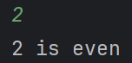

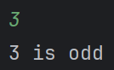

**2.** Write a program to find out the largest number among four numbers A, B, C and D.

**Code:**

import java.util.Scanner;  
  
class Main  
{  
 public static void main(String[] args)  
 {  
 Scanner input = new Scanner(System.in);  
  
 int A = input.nextInt();  
 int B = input.nextInt();  
 int C = input.nextInt();  
 int D = input.nextInt();  
 char ch = 'A';  
  
 if (A < B)  
 {  
 int t = A;  
 A = B;  
 B = t;  
 ch = 'B';  
 }  
 if (A < C)  
 {  
 int t = A;  
 A = C;  
 C = t;  
 ch = 'C';  
 }  
 if (A < D)  
 {  
 int t = A;  
 A = D;  
 D = t;  
 ch = 'D';  
 }  
  
 System.out.println(ch + " is the largest number.");  
 }  
}

**Input - Output:**

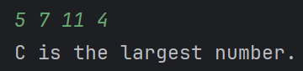

**3.** Write a program that reads a year from the keyboard and determines whether it is a leap year or not.

**Code:**

import java.util.Scanner;  
  
class Main  
{  
 public static void main(String[] args)  
 {  
 Scanner input = new Scanner(System.in);  
  
 int year = input.nextInt();  
  
 if ((year % 4 == 0 && year % 100 != 0) || (year % 400 == 0))  
 {  
 System.out.println("Year " + year + " is a leap year");  
 }  
 else System.out.println("Year " + year + " is not a leap year");  
  
 input.close();  
 }  
}

**Input - Output:**

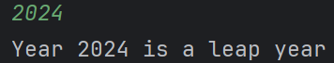

**4.** Write a program that computes an employee's gross pay and net pay using the formulas-

Gross = Hours * Rate

Net = Gross — Tax

Tax is subtracted from the gross only if an employee earns more than TK.5000. Otherwise deduct no tax. Tax rate is 5% of gross pay.

**Code:**

import java.util.Scanner;  
  
class Main  
{  
 public static void main(String[] args)  
 {  
 Scanner input = new Scanner(System.in);  
  
 int hour = input.nextInt();  
 double rate = input.nextDouble();  
  
 double gross = hour * rate;  
 double net = gross;  
  
 if (gross > 5000)  
 {  
 net -= (gross * 5) / 100;  
 }  
  
 System.out.println("Gross Pay : " + gross);  
 System.out.println("Net Pay : " + net);  
 }  
}

**Input - Output:**

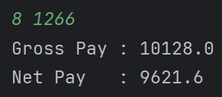

**5.** Write a program which receives the score of a student and display the grade according to the following classification:

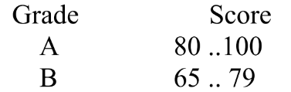

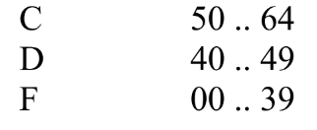

**Code:**

import java.util.Scanner;  
  
class Main  
{  
 public static void main(String[] args)  
 {  
 Scanner input = new Scanner(System.in);  
 int score = input.nextInt();  
 String grade;  
  
 if (score >= 80 && score <= 100) grade = "A";  
 else if (score >= 65) grade = "B";  
 else if (score >= 50) grade = "C";  
 else if (score >= 40) grade = "D";  
 else if (score >= 0) grade = "F";  
 else grade = "Invalid input";  
  
 System.out.println("Grade: " + grade);  
 }  
}

**Input - Output:**

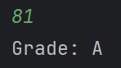

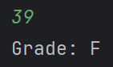

**6.** An electricity board charges the following rates to domestic users to discourage the large consumption of energy:

For the first 100 units : Tk. 1.75 per unit

For next 200 units: Tk. 2.25 per unit

Beyond 300 units: Tk. 3.50 per unit

All users are charged a minimum of Tk. 100/=. If the total cost is more than Tk.1000/= then an additional surcharge of 15% is added.

**Code:**

import java.util.Scanner;  
import java.lang.String;  
  
class Main  
{  
 public static void main(String[] args)  
 {  
 Scanner input = new Scanner(System.in);  
 System.out.print("Name : ");  
 String name = input.nextLine();  
 System.out.print("Number of units consumed : ");  
 double unit = input.nextDouble();  
  
 System.out.println("Hello, " + name + '!');  
 System.out.println("You consumed " + unit + " unit of energy");  
  
 double charge = 100;  
 if (unit > 300)  
 {  
 charge += (unit - 300) * 3.50;  
 unit = 300;  
 }  
 if (unit > 100)  
 {  
 charge += (unit - 100) * 2.25;  
 unit = 100;  
 }  
 charge += unit * 1.75;  
  
 if (charge > 1000) charge += (charge * 15) / 100;  
  
 System.out.println("You are charged TK " + charge + "/=");  
 }  
}

**Input - Output:**

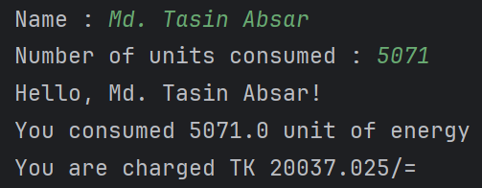

**7.** Write a program that plays the game of "Rock, paper, scissors". In this game, two players simultaneously say "rock", "paper" or "scissors". The winner is one whose choice dominates the other. The rules are: paper dominates (wraps) rock, rock dominates (breaks) scissors, and scissors dominate cut paper.

**Code:**

import java.util.Scanner;  
  
public class Main {  
 public static void main(String[] args) {  
 Scanner scanner = new Scanner(System.*in*);  
  
 System.*out*.println("Let's play Rock, Paper, Scissors!");  
 System.*out*.print("Enter Player 1's choice (rock, paper, or scissors): ");  
 String player1Choice = scanner.nextLine().toLowerCase();  
  
 System.*out*.print("Enter Player 2's choice (rock, paper, or scissors): ");  
 String player2Choice = scanner.nextLine().toLowerCase();  
  
 if (player1Choice.equals(player2Choice))  
 {  
 System.*out*.println("It's a tie!");  
 }  
 else if (player1Choice.equals("rock") && player2Choice.equals("scissors") ||  
 player1Choice.equals("scissors") && player2Choice.equals("paper") ||  
 player1Choice.equals("paper") && player2Choice.equals("rock")) {  
 System.*out*.println("Player 1 wins!");  
 }  
 else  
 {  
 System.*out*.println("Player 2 wins!");  
 }  
 }  
}

**Input - Output:**

